Kol Simcha Torah Gazette
For tazria-metzora 5786
Vol 10 Issue 27 (Whole #492) 1 Iyar 5786/ April 17, 2026
Printed L’illuy nishmas Nechama bas R’ Noach, a”h
For a free subscription, please forward your request to keren18@juno.com
Past emails can be found on the website ShabbosStories.com under Brooklyn Torah Gazette

Why Did G-d Create
Man Last in Creation?
Compiled by Mordechai Rubin
From the Teachings of the Lubavitcher Rebbe
Rabbi Menachem Mendel Schneerson, Zt”l

This week's Torah portion, Tazria, deals with the laws pertaining to man - matters of ritual impurity and how to purify oneself after becoming impure. A discussion of these laws follows the discussion in previous chapters which pertain to animals - which are pure and which are impure, and animal sacrifices.
"The same way that man's creation took place after all the other animals and birds, so are the laws pertaining to man to be found in the Torah after the laws dealing with animals," our Sages teach.
The Talmud and Midrash offer several explanations as to why man was created only after very other creation was complete. One of them is so that man would arrive in a world ready and completed and be immediately able to perform mitzvot (commandments). A second reason given is that if man's behavior is not worthy and proper, one can say to him, "Even a mosquito was created before you, even an earthworm preceded you."
These two explanations express the dual nature of the essence of man. The first presents man in the role of the crown of Creation, for whom G-d prepared everything in advance. The second explanation stresses the relative unimportance of man as compared to all the other animals, to the point that even the mosquito came first.
The first reason stresses man's merit and is related to the soul every Jew. The second explanation, stressing the unimportance of man, relates to the physical body.
By virtue of the G-dly soul, which is literally a part of G-d, man stands on a level higher than all other creations. This aspect of man cannot be changed even if, G-d forbid, he sins. However, because of his physical body, man is concurrently lower than even a mosquito; an animal does not have free choice and can only carry out the function for which it was created. Man is the only creature that can chose not to carry out G-d's will.
Because man has the ability to lower himself below all other animals, the laws pertaining to him are written in the Torah only after the laws pertaining to the animals.
This contradiction in man's nature raises the question, "How is it possible to be, at the same time, on both a lofty exalted level and yet lower than all other creature?"
Man's subordinance is hidden within a great virtue. Precisely because of man's corporeal nature, he is able to fulfill the purpose of Creation. G-d's will is that the lofty soul should come down and "clothe itself" in a physical body, to elevate and purify the body. The purpose of creation is that man ("adam"), created from earth ("adama") should uncover and fulfill the potential of his soul and elevate his corporeal nature.

Reprinted from the Parshat Sasria 5786 email of L’Chaim, a publication of the Lubavitch Youth Organization in Brooklyn, NY. Adapted from the works of the Lubavitcher Rebbe.

Rav Avigdor Miller on
the Disease of Tzara’as

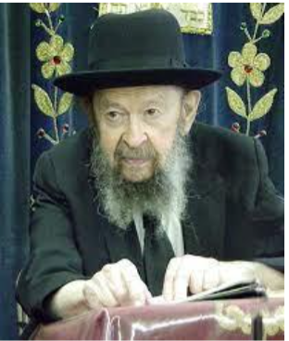

QUESTION: Why did Hashem give Na’aman the type of tzara’as that only a Jew is supposed to have as written in the Torah?
ANSWER: Na’aman became a metzora. It wasn’t a Jewish tzara’as. Tzara’as is not a Jewish sickness.

QUESTION: But the type of tzara’as in the Torah is meant for Yidden. And when Geichazi contracted his tzara’as, he was put out of the city and that’s only done if you have the tzara’as of the Torah.
ANSWER: Na’aman the general? He wasn’t driven out of the city. Among goyim they didn’t follow the Torah laws of tzara’as.

QUESTION: Geichazi was sent out. And he contracted Na’aman’s tzara’as.
ANSWER: So?

QUESTION: So, if he contracted Na’aman’s tzara’as, he had to have the tzara’as that’s written in the Torah, where you get ostracized from the city. Because he was one of the four who were outside the city.
ANSWER: If a Jew had tzara’as, chalilah, a gentile could catch it from him, no question about it. It’s no kasha at all. When a Jew has a cold, can a gentile catch a cold from him?

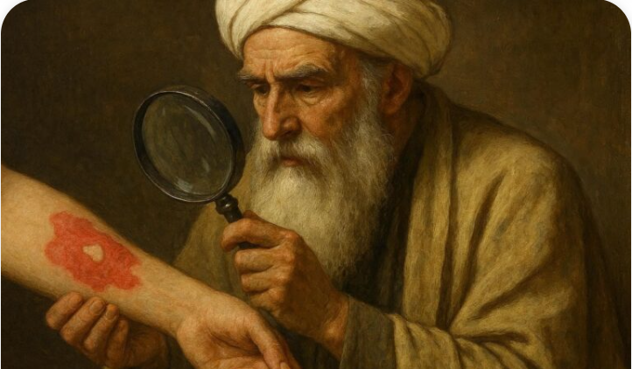

QUESTION: But Geichazi caught it from Na’aman?
ANSWER: It makes no difference. A cold is a cold. A sickness is a sickness.
Reprinted from the Parshas Vayikra 5786 edition of Toras Avigdor. (Transcribed from a classic Thursday night hashkafah lecture delivered by Rav Avigdor Miller in November 9, 2000.)
******************************************************************
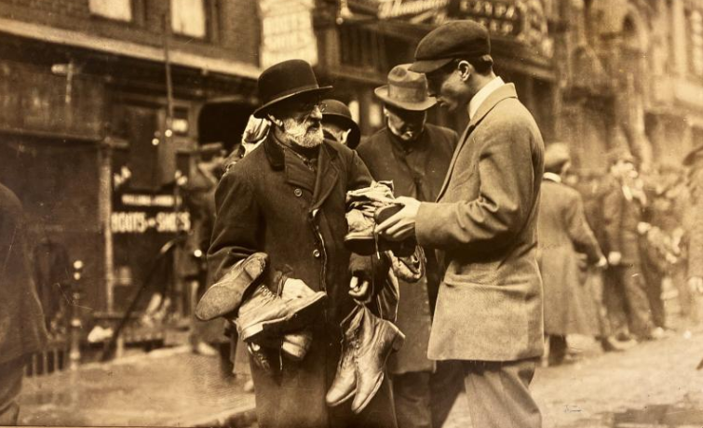
Shoes Peddler on Lower East Side circa 1930-34 (photo by Percy Loomis Sperr)

Thoughts that Count
for Our Parsha

If a man shall have on the skin of his flesh (Lev. 13:2)
When discussing the phenomenon of leprosy and the various appearances such a plague could assume, the Torah uses the word "adam" (man), a term reserved for expressing man's finest attributes and characteristics. Why doesn't the Torah use any of the three other Hebrew words for man - ish, gever, or enosh? The plague of leprosy appeared only "on the skin of his flesh" - on the most external part of a person. Years ago, when G-d afflicted someone with leprosy as a punishment for his deeds, it affected only his most external self, for the inner person was spiritually healthy and not deserving of punishment. Nowadays we have no such phenomenon, as the Biblical leprosy differed from the modern-day disease bearing the same name. In our time, it's not just the external part of ourselves we must work on and purify.
(Sefer Maamarim)

When a woman conceives and gives birth (Lev. 12:2)
The potential contained within a seed is virtually limitless. When properly nurtured, a seed will develop into a mature tree, which, in turn, will yield more seeds with the potential for growth and regeneration. Our service of G-d must be performed in a similar manner. A good deed must not be self-limiting; a Jew must always strive to ensure that his actions have far-reaching effects, bearing fruit in the next generation as well. (Likrat Shabbat, #22)

He shall be brought to Aaron the kohen or to one of his sons the kohanim (Lev. 13:2)
Only a kohen (priest) was allowed to determine whether or not a plague was leprous, a severe affliction necessitating that the sufferer to be sent outside the camp for seven days. Only a kohen, whose job is to bless the Jewish people with the priestly blessing, could fully appreciate the magnitude of being sent outside the warm and loving Jewish camp. He could therefore, be relied upon to try all possible means to pronounce the individual clean. (The Lubavitcher Rebbe)

Reprinted from the Parshat Sasria 5786 email of L’Chaim, a publication of the Lubavitch Youth Organization in Brooklyn, NY.

My Father Survived the Holocaust. Today He Has Over 600 Descendants
By Amrom Gottesman

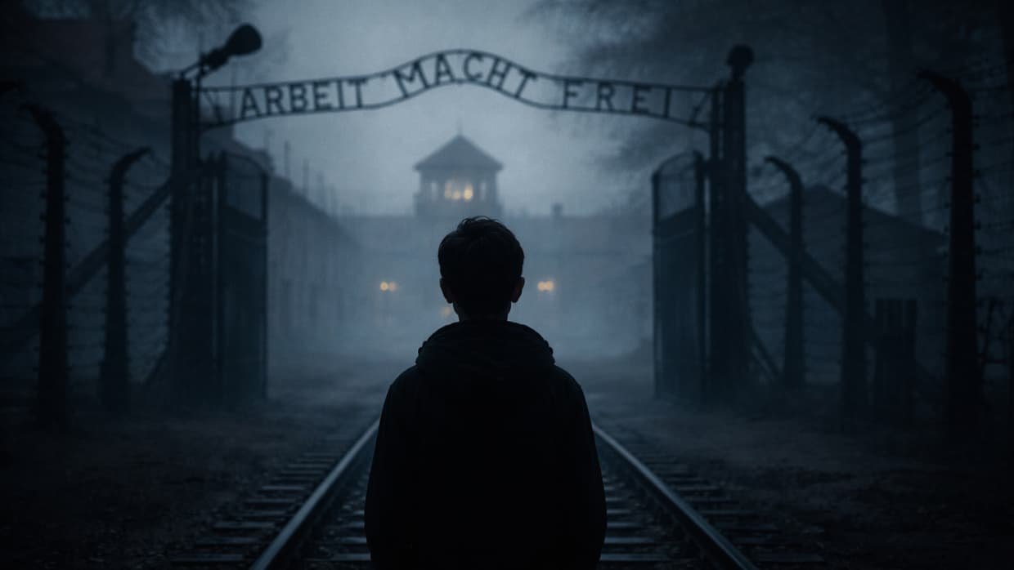

In 1944, a teenage boy arrived at Auschwitz and watched his mother and siblings sent to the gas chambers. This is how Leibish Gottesman survived, and what he built from the ashes.
It was 1944. A teenage boy, Aryeh Leibish Gottesman, had been rounded up by the Nazis with his mother and seven siblings. They were forced into cattle cars full of thousands of Jewish prisoners. Their destination? Auschwitz-Birkenau in Poland.
Aryeh, who went by his middle name, Leibish, and the other prisoners suffered on the train. There was only one small toilet and one tiny window, offering a little bit of fresh air. There was no place to sit. The older people stood the entire time. The children sat on the floor under the legs of the older people and cried their hearts out. Everyone was given a little bit of water, but no food.
The train stopped several times for short intervals. One of these times was in Budapest. People who were on the same wagon as Leibish encouraged him to escape. “Do not be fools!” they yelled. “You can see where we are heading. Save your lives and jump out of the train!”
Leibish’s mother had gotten sick on the train, and he didn’t want to abandon her. “I can’t jump because I cannot leave my mother alone!”
After three horrendous days, they finally arrived at their destination in Auschwitz on June 11th, 1944, the 20th of Sivan, a day when many calamities occurred throughout Jewish history. It was a Sunday, and for some unknown reason, the people were forbidden to leave the train for the entire day. When night came, the passengers were callously emptied from the train and forced to leave behind all their possessions.
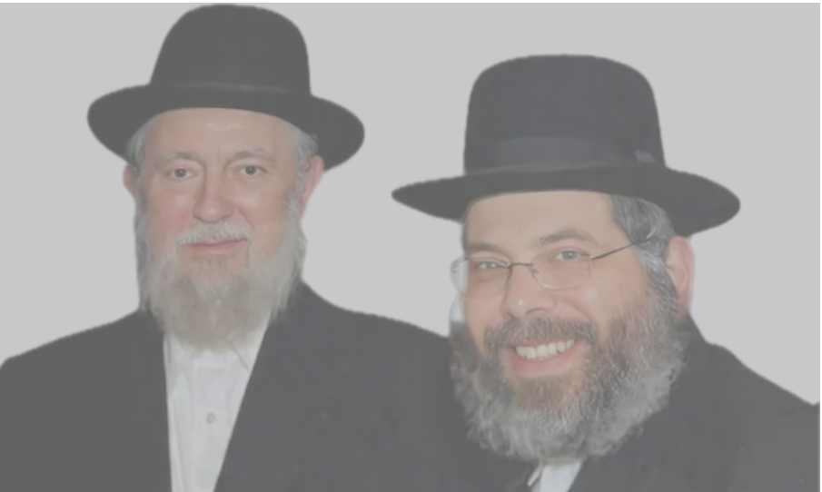
The author, right, with his father

Right away, Leibish and the others saw smoke coming out of the crematorium. In their worst nightmares, they never could have imagined what this smoke was, and that many of their relatives had already been incinerated in these ovens. Leibish thought the smoke was coming from a bakery.

The Flick of a Finger
Leibish and his fellow passengers filed past the infamous “angel of death,” Dr. Josef Mengele, who, with the flick of his finger, could condemn you to death. To the right meant life, to the left meant the gas chambers. He decided the fate of millions of people. You would only be given the chance to live if you were 18 or older and you could work.
Leibish, who was tall and wore two coats, looked like a well-built adult. He was sent to the right. His mother and six of his siblings – save for one brother – were sent to the left.
That was the last time Leibish saw them. A few days later, he learned the terrible truth: they had been sent to the gas chambers.
His entire world was shattered. But somehow, he has been spared.

Surviving the Unsurvivable
Everyone who survived the lines was shaven from head to toe. They were scrubbed from head to toe with a metal brush which was excruciating.
Once this brutal process was over, the prisoners was ordered into the washrooms. The Nazis maneuvered either extremely hot or extremely cold water to come out of the showerheads in order to torment the prisoners and strip them of their dignity.
Leibish was taken to an empty barrack, waiting for the next transport to Germany. For the next month he slept on the freezing floor with the other prisoners and only received a quarter of a slice of bread daily.
On July 11, he was taken to a concentration camp called Allach in Germany, from where he was transferred for assigned slave laborer in Muhldorf, a subdivision of Dachau. After two weeks of backbreaking labor, he fainted and was taken to a clinic. The doctor diagnosed him with life-threatening pneumonia.
They decided to send him to the big clinic “gas chamber” in the main concentration camp in Dachau. He was put on a truck, together with two other people. One was dead, and the other was a person who had also been diagnosed with pneumonia.

A Wrong Turn
The truck driver mistakenly took them to the clinic designated for POWs. This error saved Leibish’s life.
At the clinic, a doctor from Holland examined him thoroughly and immediately noticed that there was a mistake: this person, with weak and skeletal body, was no POW. The doctor asked him: “What are you doing here?”
Leibish told him the truth: “Ich bin Jude -- I am a Jew. The doctor took Leibish’s documents and told him, “Do not worry. I will take care of you and heal you.”
Like all the other Jews in Nazi-occupied territory, there was the letter “J” written on Leibish’s identification card, which meant he was Jewish. The doctor took a pen and quickly changed the letter from a “J” to an “S,” which stood for Slovakia. This was true because Leibish was a Slovakian native. This way, the doctor could now “legally” keep him under his custody and care.
While Leibish recovered, he eventually became ill several more times in Dachau, and he survived it because of another guardian angel: Mr. Springer, a tailor and shoemaker in the camp who hired Leibish to work on shoes. Leibish earned his share in bread which sustained him until his liberation.
Finally, in March 1945, the thunderous noise of large bombs was heard in Dachau. In the ears of the prisoners, these frightening booms were the best sound, heralding their imminent freedom. The allied forces were inching ever closer.

Building His Legacy After the Holocaust
The panicked Nazis arranged a transport for Leibish and the other prisoners to an open, deserted field in Seiwald, underneath the Alps of Austria, for their final elimination. Within hours, however, the Nazis retreated and escaped, afraid of falling to the Allied forces.
In July 1945, Leibish was finally liberated. At this point, he was 6’2 and weighed 99 pounds. He had survived, but barely.
He traveled to his hometown only to learn the devastating news: It had been destroyed. Life as he knew it was gone forever. Only his brother Kalman had made it through.
Leibish knew he had to leave Europe, so he emigrated to America to study in yeshiva and devote his life to Torah learning. He learned 18 hours per day in yeshiva and became the star pupil. In 1956, he married Rikel, also a Holocaust survivor who lost both of her parents at six years old. Together, they had seven children: four boys and three girls.
In 2016, at the age of 88, Leibish passed away, leaving behind his wife, children, and grandchildren. His legacy continues with five living generations, and over 600 descendants, who are proud, observant Jews. They carry on his family name and memory.

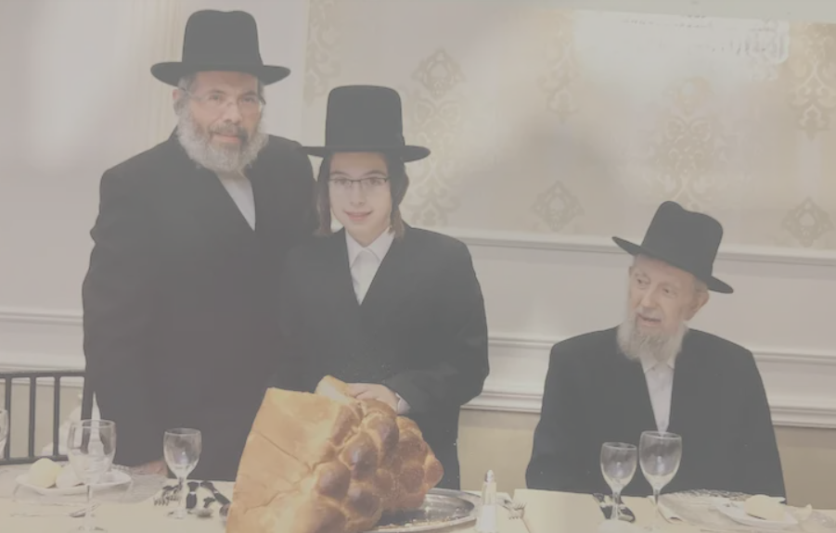

The Legacy of Leibish – And All Survivors
With the rise of antisemitism throughout the world, the story of Leibish and many other survivors give us hope and inspiration, showing that miracles do occur.
This Yom HaShoah (Holocaust Remembrance Day), we must do more than mourn. We must tell these stories — in our homes, in our classrooms, to Jews and non-Jews alike. Survivors are leaving us. Soon, firsthand accounts will be gone. The stories that remain are not just history. They are a lifeline.
Leibish's story is proof that miracles happen. And that the most powerful act of defiance against genocide is simply — to live, and to keep going.

Reprinted from the current aish.com website.

No, Jews Are Not
Museum Artifacts
By Sofya Sara Esther Tamarkin

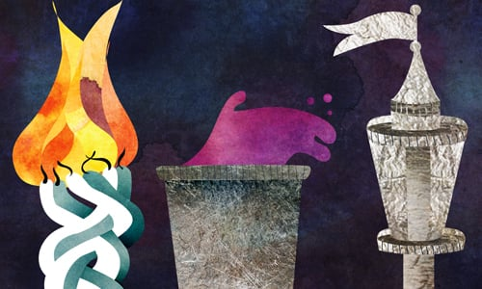
Art by Sefira Lightstone

To celebrate our 10th anniversary, my husband and I took a trip to Australia.
Having grown up in the former Soviet Union, we both had little knowledge of our Jewish identity and were taking slow steps to reclaim our heritage.
My return to my heritage was inspired by a blessing of the Rebbe when I was 13 years old.
To be honest, learning about traditions overwhelmed me. There was so much I didn’t know. Shabbat, kosher laws, mikvah, prayer, Torah learning … the list was endless. The more I learned, the more I realized how much I still did not know.
I was motivated to grow, to make up for the years spent behind the Iron Curtain steeped in Soviet propaganda, where schools preached atheism and, for generations, students could not graduate unless they passed an exam “proving” the absence of a Higher Power.
I viewed every mitzvah as a precious diamond I was determined to collect. Yet my husband and I questioned how much we could actually incorporate into our daily lives. Finding it more than we could handle at one point, we slowly plateaued.
That is exactly when, by Divine Providence, we set out on a cruise to Australia.
When we docked in Melbourne, we decided to visit the Jewish museum.
Joined by a group of about thirty people, mostly non-Jews, we followed our guide from one exhibit to the next. Behind the glass were the displays of Jewish objects.
Among the books, documents, and ritual items, we saw a beautiful Havdalah set with a candle holder, spice box, and goblet. Our guide pointed it out and described it as “a ceremonial set that was historically used to mark the end of the Sabbath.”
I was immediately struck by the jarring use of past tense and simply couldn’t hold back. I moved a little closer to the guide and politely informed her that the Havdalah ceremony is not a “thing of the past” but a tradition upheld every week by Jewish people all over the world. She listened as I finished my explanation and, with the rest of the group looking on, challenged me: “Let me clarify: This is still an ongoing part of Jewish tradition? You do this weekly?”
All eyes were on me. I was put on the spot.
I didn’t want to lie. But I did not, in fact, make Havdalah weekly. Choosing my words carefully, I replied, “I certainly will make Havdalah this upcoming Saturday night.”
The tour moved on but I trailed behind the group, dwelling on the way the guide hadn’t realized that Jewish people are not museum exhibits. We were a living and breathing organism, fueled by the Torah and mitzvahs given to us by the Creator of the world.
Our ritual items are as relevant today as they were 3,000 years ago.
American writer of the last century, Walker Percy, famously wrote:
Where are the Hittites? Why does no one find it remarkable that in most world cities today there are Jews but not one single Hittite, even though the Hittites had a great flourishing civilization while the Jews nearby were a weak and obscure people? When one meets a Jew in New York or New Orleans or Paris or Melbourne, it is remarkable that no one considers the event remarkable. What are they doing here? But it is even more remarkable to wonder, if there are Jews here, why are there not Hittites here? Where are the Hittites? Show me one Hittite in New York City.
We were in Melbourne and there were certainly no Hittites around. But there were Jews.
I did, in fact, keep my promise, and from that week forward, we made sure to always end Shabbat with Havdalah.
Every week, as my husband and I usher out the holy day, I imagine reaching through the Melbourne museum glass and retrieving the Havdalah set that inspired me to take the plunge.
In fact, Havdalah may now be my favorite tradition, for every week I remind myself that we are the chosen people, continuously living in accordance with Torah. This is the eternal story of Jewish people. This is who we are and who we will forever be. Am Yisrael chai.

Reprinted from the current website of Chabad.Org

